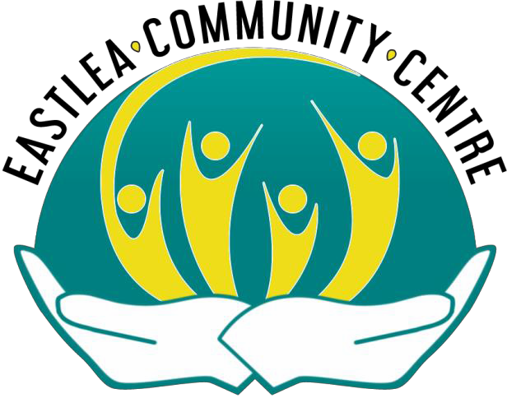

SEAHAM EASTLEA AND DISTRICT COMMUNITY ASSOCIATION

(Eastlea Community Centre (ECC))

Trustees’ Annual Report

1 April 2022 to 31 March 2023

Charity Number: 1160391

Stockton Road Seaham
Co Durham
SR7 8DX

Tel: 0191 581 2399
Fax: 0191 513 1384
Email: eastleacc@yahoo.co.uk

Seaham Eastlea and District Community Association
Trustees’ Annual Report and Financial Statements 31st March 2023
First Charity Trustees
Mr John Bainbridge
Mr Ronald Farn
Trustees
Miss Emily Fox
Mrs Sharon Bell
Mr Craig Bell
Mission Statement
To provide activities of interest for a functioning community across the generation spectrum under the four
core themes of; Health & Wellbeing, Education & Training, Recreation & Leisure and Support for Employment and Enterprise.
Objectives
The objectives of the charity are set out in the constitution and are summarised as follows:
The objectives of the CIO are to establish and run a Community Building and to promote for the benefit of
the inhabitants of Seaham and surrounding area (“area of benefit”) without distinction of sex, sexual orientation, age, disability, nationality, race or political, religious or other opinions the provision of facilities
for recreation or other leisure time occupation of individuals who have need of such facilities by reason of their youth, age, infirmity or disablement, financial hardship or social and economic circumstances or for
the public at large in the interests of social welfare and with the object of improving the conditions of life of
the said inhabitants.
Structure, Governance and Management
Type of Governing Document
Eastlea Community Centre (the Centre) is a constituted Charitable Incorporated Organisation (CIO),
registered with the Charity Commission in February 2015 under the charity number 1160391. Originally constituted in January 1971, as an association under the charity number 507192, dissolved in March 2015 and a ‘Deed of Transfer’ completed.
Our governing constitution, adopted from the Charity Commission’s ‘Foundation Model’ CIO was last
amended 5 November 2014. The ‘Foundation Model’ is for charities whose only voting members will be the charity Trustees.
The Charitable Incorporated Organisation (CIO) is a new legal form for a charity, which is not a limited
company or subject to company regulation.
The Charities Act 2011 creates the basic legal framework for the CIO. This framework is completed by
regulations:
- The Charitable Incorporated Organisations (General) Regulations 2012
- The Charitable Incorporated Organisations (Insolvency and Dissolution) Regulations 2012
We registered with the Information Commissioners Office (ICO) on 9 June 2015. The UK’s independent
authority set up to uphold information rights in the public interest, promoting openness by public bodies and data privacy for individuals. This is renewed annually.
1

Seaham Eastlea and District Community Association
Trustees’ Annual Report and Financial Statements 31st March 2023
On 25 May 2018 the new General Data Protection Regulations (GDPR) came into force. Leading up to
this date a rigorous process has taken place, policies and procedures reviewed and staff training completed to ensure we comply with the new regulations. We are confident that we have improved our
systems in all areas and will continue to regulate and monitor our practices.
Trustee Selection Methods
Trustees are selected and elected in line with the Charity Commission’s Foundation Model Constitution of
a Charitable Incorporated Organisation whose only voting members are its charity Trustees. The following declarations, knowledge of and information form part of our selection and recruitment process:
Trustees Eligibility Declaration, Working with Vulnerable Groups, Trustee eligibility and responsibility,
Enhanced DBS and Personal Benefit.
The Trustees are appointed by the Board in the Annual General Meeting.
Organisational Structure
Following the staffing changes made in early March of 2022 the roles of Irene Waller (Interim Finance
Manager) and Monica Christie (Interim Centre Manager), reverted to their original standing of IW once again taking the role of Centre Manager and finance officer and MC working as office auxiliary with effect from August 2022.
In June of 2022 the services of Caroline Gitsham a HR consultant were accepted for on a free and non-
gratis basis to help with core running issues and funding shortfalls.
Both Centre Manager and Auxiliary have agreed to part time working to save on wage bills from September
2022.
Trustees worked with Irene Waller to schedule a retirement plan for her to retire in late 2023.
The Nursery Manager is responsible for two full time and five part time Early Years Practitioners in addition
to any supply staff needed and manages the day-to-day running of the Nursery. In November 2022 the nursery expanded into the former IT suite of the centre to accommodate more places to meet demand for two year old places in the nursery which were limited by the resources of the nursery in its current form. In addition to this, our Nursery Manager began to manage our Caretaker in February 2022, and this was on going into this year. Both the Centre and Nursery Managers are responsible for volunteers within their respective areas of work. Craig Bell continues to be the Nominated Individual for the Nursery, registered with Ofsted and line manages the Nursery Manager. The Trustees are responsible for all employed staff, and the Interim Centre Manager, Interim Finance Manager and Nursery Manager report directly to the Trustees.
The Trustees, who have a wealth of knowledge and experience, are all local people, who know the
community well. They are responsible for the overall management of the Centre and give their time freely. They are legally and morally bound to manage the Centre’s property, in a responsible and productive
manner, and have an obligation to act solely for the benefit of the Centre’s beneficiaries. The Trustees meet every six weeks, where discussions and decisions relating to the operations of the Centre and its
activities are agreed and put into practise. All relevant policies, procedures, governing document, bank account and insurances are in place.
The charity relies heavily on the support of its volunteers to achieve its objectives.
We provide work placements for apprenticeships and traineeships.
2

Seaham Eastlea and District Community Association
Trustees’ Annual Report and Financial Statements 31st March 2023
Equality and Diversity
Eastlea Community Centre is firmly committed to equality and diversity in all of its activities. We recognise
that the strength of the Centre is built on the understanding of individual strengths and differences and seek to respect these. We are committed to promoting equality of opportunity within our Centre and with
external partners and users. We recognise that some groups and individuals in society are disadvantaged
because of prejudices and discrimination experienced. We seek to ensure that our Centre respects and includes everyone and that no one receives less favourable treatment on the basis of sex, sexual orientation, age, disability, nationality, race or political, religious or other opinions (as stated in our Objects).
Objectives, Activities and Achievements
Eastlea Community Centre is in the Deneside ward of County Durham. We serve the immediate and
surrounding areas with a range of activities to suit the community from birth upwards. The Centre is open Monday to Thursday, from 8.30am to 8.30pm, and on a Saturday and Sunday when the need arises for
special events. Our projects and activities cater for those from birth to the elderly, which includes those who are socially isolated, disabled, children and young people, the elderly, men's group, women only
group, mental health and the unemployed. We deliver our services under four main themes of Health and Wellbeing, Education and Training, Recreation and Leisure and Support for Enterprise and Employment.

Eastlea Community Centre is proud to have gained the Hallmark Levels 1 and 2 with ACRE (Action with Communities in Rural England). These are quality standards schemes rewarding and recognising good practice for village halls and community buildings.

Eastlea Community Centre is a City and Guilds Approved Centre.
Below is an outline of activities that we bring to the community to meet our objectives:
Regular Activities delivered by Volunteers
Jujitsu, Luncheon Club (Warm Hub), Childrens Holiday Activities, CREE-ATION Men’s Group, Tea & Chat
Women’s Group, Teeny Tots, FAB - Fridays are Brill, NE First Credit Union, Tea and Chat Drop in, Short Mat Bowls, Art, Louie’s Place Community Café, an I.T. Group and “Dance to a Tea” ballroom
dancing/afternoon tea group.
Regular Activities delivered by other organisations and service providers.
Zumba, Tai Chi, Karate, and Timesteps Dance Group.
NHS - Health Trainers carry out one to one consultation with clients
East Durham Trust provides debt, housing and energy advice for low-income families who find themselves
in financial difficulties causing a negative effect on their wellbeing. In addition to the centre is a distribution point for the “FEED Project”, Food Bank where food parcel claimants can pick up their parcel, also a
collection point for food donations from individuals in the community to support those in need.

NE First Credit Union which allows individuals to save and borrow safely in times of need.
Durham County Council, Leisure In The Community and the East Durham Area Action Partnership asked
the Centre to host a tea dance followed by afternoon tea in our hall for our local community to learn new social dances in a range of styles which was instated in Jan 2023.
Children & Young People’s Services delivered by the Centre
Our Children and Young People’s Services provide activities for children and young people, aged from
birth to 18 years.
Community Ofsted Registered Nursery – We continue to operate a not-for-profit community Ofsted
Registered Nursery, providing 68 places per day over two sessions each day due to the expansion of the
3

Seaham Eastlea and District Community Association
Trustees’ Annual Report and Financial Statements 31st March 2023
nursery into the former IT suite. Sessions are 8.30am to 11.30am and 12noon to 3pm, where children
aged two to four years access free educational entitlement. We provide places for children with Special Educational Needs/Disability (SEND). We currently have an Ofsted judgement of ‘Outstanding’ gained in November 2022. We are an accredited Sun Safe and Millie’s Mark Nursery.
We celebrate special days/events throughout the year, providing diverse learning opportunities for our
children. We invite families to share these experiences and external organisations to share their knowledge and experiences with our children.
This has been another excellent year where we have continued to receive very positive feedback from
parents and professionals who have accessed our service. All places are taken each term, with waiting lists in place.
FAB (Fridays are Brill) – A very popular, weekly activity in which we engage with up to 42 children from
five years upwards. Each Friday, after school, a variety of creative, physical and social activities are delivered. Tea is provided. The children have also had the opportunity, over the past year, to be involved
in external community events and visits. Special celebration days/events are promoted and celebrated.
We welcomed FAB back to the Centre in September 2021, following its temporary cancellation during COVID-19.
Teeny Tots – A weekly activity, for little ones from birth up to four years and their parents/carers. Lots of
age-appropriate activities to encourage development, promote learning through play and develop social skills. Special celebration days/events are promoted and celebrated. This is a friendly, social group, which
also offers peer support for parents and carers. We welcomed Teeny Tots back to our Centre in July 2021, following its temporary cancellation due to COVID-19.
Monthly Councillor Surgeries
This provides a monthly drop-in surgery and the opportunity for local residents to take up enquiries and
chat with Councillors.
4
Weekly Activities at a Glance at Eastlea Community Centre
MONDAY
Tots ‘R’ Us Ofsted Registered Nursery
8.30 am -11.30 am & 12 pm - 3 pm
Tai Chi
10.45 am – 11.45 am
Louie’s Place Community Café
11 am – 1 pm
Teeny Tots, 0 – 4 years
- pm – 2 pm
CREE-ATION Men’s Group
- pm – 4 pm
Nuvo Seated Dance
2.30 pm - ?
Timesteps Dance Groups (Age 5 – Adult)
6 pm – 9 pm
TUESDAY
Tots ‘R’ Us Ofsted Registered Nursery
8.30 am -11.30 am & 12 pm - 3 pm
Carpet Bowls
- am – 12 noon
N.E. First Credit Union Pay point
- am – 12 noon
Tea & Chat Women’s Group
- pm – 2 pm
Dance To A Tea
2 pm – 4 pm
Jobsearch
5 pm – 6 pm
Jujitsu
7 pm – 8.30 pm
WEDNESDAY
Tots ‘R’ Us Ofsted Registered Nursery
8.30 am -11.30 am & 12 pm - 3 pm

Seaham Eastlea and District Community Association
Trustees’ Annual Report and Financial Statements 31st March 2023
Special Annual Activities
•
•
•
Christmas Fayre & Grotto
Polling station for local, regional and national elections
Eastlea Community Centre is proud to house and display the Seaham Colliery (Seaham Lodge) and Vane Tempest (Vane Tempest Lodge) Miner’s Banners. Each year they are paraded through the streets of Seaham, alongside colliery bands. The parades set off early in the morning, before arriving in the city of Durham to join the Durham Miners’ Gala event.
Occasional Activities
•
•
•
Non-term time activities for children during Half-Term
Services – Photocopying, Printing, IT facility and meetings
Private functions – wedding receptions, birthday parties and christenings
Projects and Achievements
-
Afternoon tea dancing sessions, funded by Durham County Council, began at Eastlea Community
Centre this year.
We held two Fun With Food activities for the children within our community, also funded by Durham County Council
Thanks to funding from Believe Housing, we were able to set up Bookworms Book Club, in which members meet once a month/every 6 weeks to discuss their latest read.
A community library was set up in the centre with support from Borderline Books, who provided us with books of many genres to ensure there was a book suitable for all ages and reading abilities. The National Lottery Community Fund provided us with funding to set up a Community Café, which
runs each Monday morning. Louie’s Place takes its name from Trustee Ronnie Farn’s wife, Louie, who was a dedicated and highly valued member of Eastlea Community Centre.
A new seated dance group, Nuvo Exercise, began to run from the centre each Monday.
Our OFSTED registered Nursery Tots ‘R’ Us secured an Outstanding grade from OFSTED following their inspection in November 2022
Our Durham County Councillors also provided us with funding to supply children within our
community with bag to school backpacks complete with stationery and water bottles, again this year.
-
-
-
-
-
-
-
5
Drop In Club
- pm – 4 pm
IT Group
- pm – 5 pm
Deneside Ward Councillor Surgery
6 pm – 7 pm (last Wed of the Month)
THURSDAY
Tots ‘R’ Us Ofsted Registered Nursery
8.30 am -11.30 am & 12 pm – 3 pm
Lunch Club
Served at 12 noon
Art
2 pm – 4pm
Karate (age 4 +)
5 pm – 6 pm
Jobsearch
5 pm – 6 pm
Zumba Mix
6.30 pm – 7.20 pm
FRIDAY
Tots ‘R’ Us Ofsted Registered Nursery
8.30 am -11.30 am & 12 pm - 3 pm
FAB Club Juniors & Seniors
4 pm – 6 pm
Jujitsu
6.30 pm – 8.30 pm
Bookworks Book Club (6 weekly)
6.30 pm - ?
SATURDAY AND SUNDAY
Children’s Parties
£50 for 2 hours

Seaham Eastlea and District Community Association
Trustees’ Annual Report and Financial Statements 31st March 2023
-
We were also able to open up our Luncheon Club for longer as a Warm Space, enabling people to
stay and keep warm in the centre following their meal, with the support and funding from Believe Housing. We introduced Bingo and other activities such as new age curling, in addition to this, 30
of the original beneficiaries of this session received free slow cookers to enable them to batch cook
at home and guarantee more warm meals.
Financial Review
Risk Management
It is the responsibility of the Trustees, with the assistance of the Centre Manager, to carry out risk
management assessments of the organisation, and to respond appropriately. The Trustees have considered the major risks to which the charity is exposed and satisfied themselves that procedures are in place to manage those risks, through the development of a Risk Management Policy and a Risk Register. Each risk assessment is reviewed for every section to which it is applicable at least twice a year to ensure that procedures are in place to avert the risk or, if that is not possible, to alleviate its impact.
Reserves Policy
The Trustees have reviewed the Reserves of the Charity. Our policy is to hold enough funds to cover three
months running costs of the Community Centre. Figures are produced by the Centre Manager and presented in the Finance Report at every other meeting of the Trustees/Management Committee.
Income/Funding Sources
Our main source of generated income continues to be from the Centre’s room hire charges. Our Nursery
plays a huge part in this by hiring three rooms, five days a week. At present our rooms are used and hired from external organisations/users, however, there is room for growth. In addition, we have had frequent fundraising events and applied to external organisations to match fund projects and salaries.
In addition to the funding secured for projects mentioned previously, smaller scale fundraising activities
take place throughout the year, initiated by staff and volunteers, which usually involve our groups and the involvement of our community. Parents and families accessing the Centre and Nursery have contributed
to raising substantial amounts and played a huge part in supporting fundraising activities throughout the
year.
We were thrilled to secure £977 in funding from Believe Housing to set up our Bookworms Book Club, as
well as £9662 to run our Warm Hub on a Thursday, providing free warm meals, activities and slow cookers to centre users.
In addition to this, our heartfelt thanks goes out to our Durham County Councillors, who agreed to fund our
Caretakers salary for an entire year as well as a new Construction Hut for our Nursery children to learn real life, valuable life skills in a fun and safe way. The total funding received for the two projects was
£20,136.

County Durham Community Foundation provided us with £1000, to provide free tea/coffee to all guests at
our Louie’s Place Café for a nine-week period.
The Durham AAP also provided us with funding from their Utility Bill Support Fund and Durham Community
Action supplied us with funding to purchase new chairs and laptops for our office staff.

We have also received a number of donations from our neighbours at The Mallard, who have hosted a number of raffles and fundraising events, to raise funds to help us continue our work in the community.

Our local community and centre users have also continued to donate to us.

Trustees’ Report
6

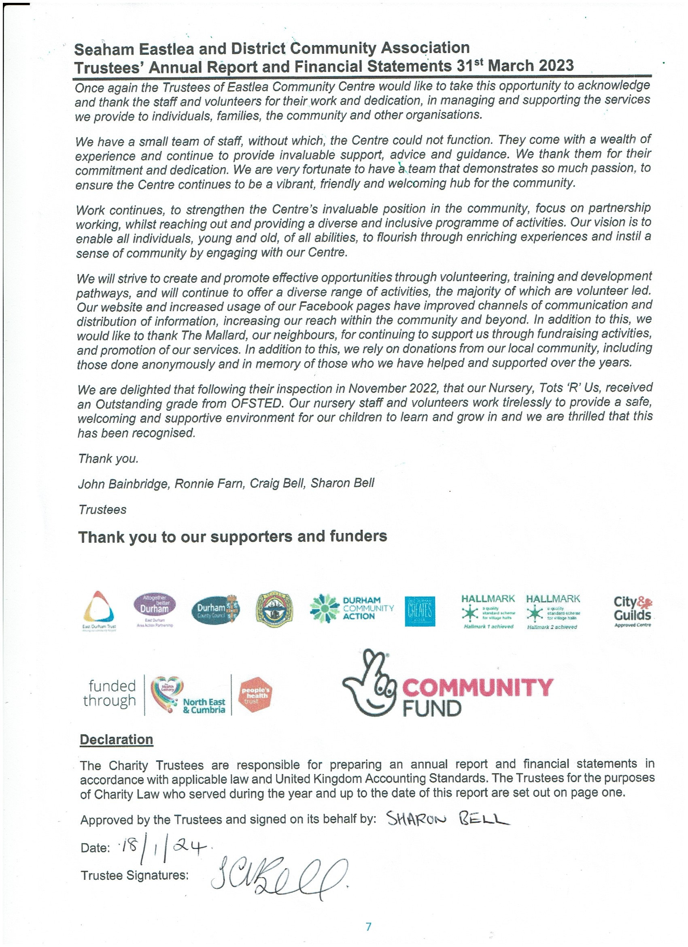

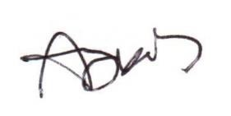
Seaham Eastlea and District Community Association
Trustees’ Annual Report and Financial Statements 31st March 2023
Independent Examiner’s Report to the Members of Seaham Eastlea and District Community
Association

I report on the accounts of the charity for the year ended 31st March 2023, which are set out on pages 9 to 15.

Respective responsibilities of trustees and examiner
The charity’s trustees are responsible for the preparation of the accounts. The charity’s trustees consider that an audit is not required for this year under section 144(2) of the Charities Act 2011 (the 2011 Act) and that an independent examination is needed.

It is my responsibility to:
•
•
examine the accounts under section 145of the 2011 Act;
to follow the procedures laid down in the general Directions given by the Charity Commission under section 145(5)(b) of the2011 Act; and
to state whether particular matters have come to my attention.
•
Basis of independent examiner’s report
My examination was carried out in accordance with the general Directions given by the Charity Commission. An examination includes a review of the accounting records kept by the charity and a comparison of the accounts presented with those records. It also includes consideration of any unusual items or disclosures in the accounts, and seeking explanations from you as trustees concerning any such matters. The procedures undertaken do not provide all the evidence that would be required in an audit and, consequently, no opinion is given as to whether the accounts present a “true and fair view” and the report is limited to those matters set out in the statement below.

Independent examiner’s statement
In connection with my examination, no matter has come to my attention:

- which gives me reasonable cause to believe that in any material respect the requirements
  - to keep accounting records in accordance with section 130 of the 2011Act; and
  - to prepare accounts which accord with the accounting records and comply with the accounting requirements of the 2011 Act have not been met; or

- to which, in my opinion, attention should be drawn in order to enable a proper understanding of the accounts to be reached.
Adam James MAAT
Eric Southwick & Co Accountants
51 The Avenue Seaham
Co Durham SR7 8NS
Date: 16/01/2024
8

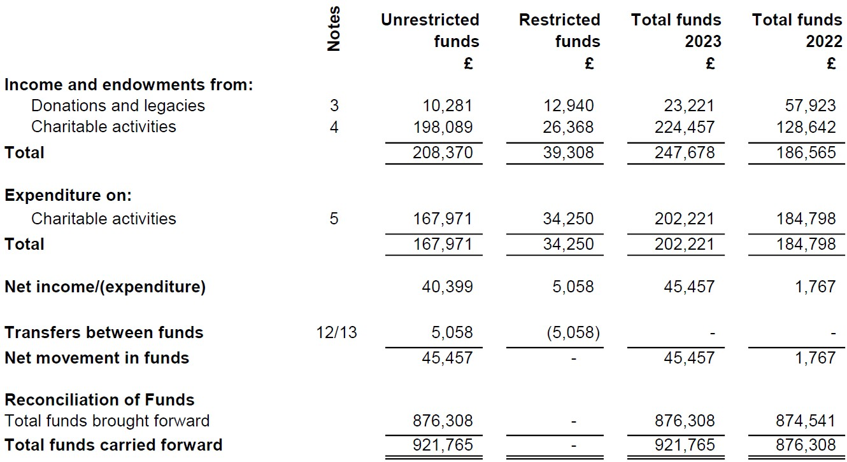
Seaham Eastlea and District Community Association
Trustees’ Annual Report and Financial Statements 31st March 2023
Statement of Financial Activities (including Income and Expenditure Account)
For the year ended 31st March 2023
The Statement of Financial Activities includes all gains and losses in the year and therefore a statement
of total recognised gains and losses has not been prepared.
All of the above amounts relate to continuing activities.
The notes on pages 11 to 16 form part of these accounts.
9

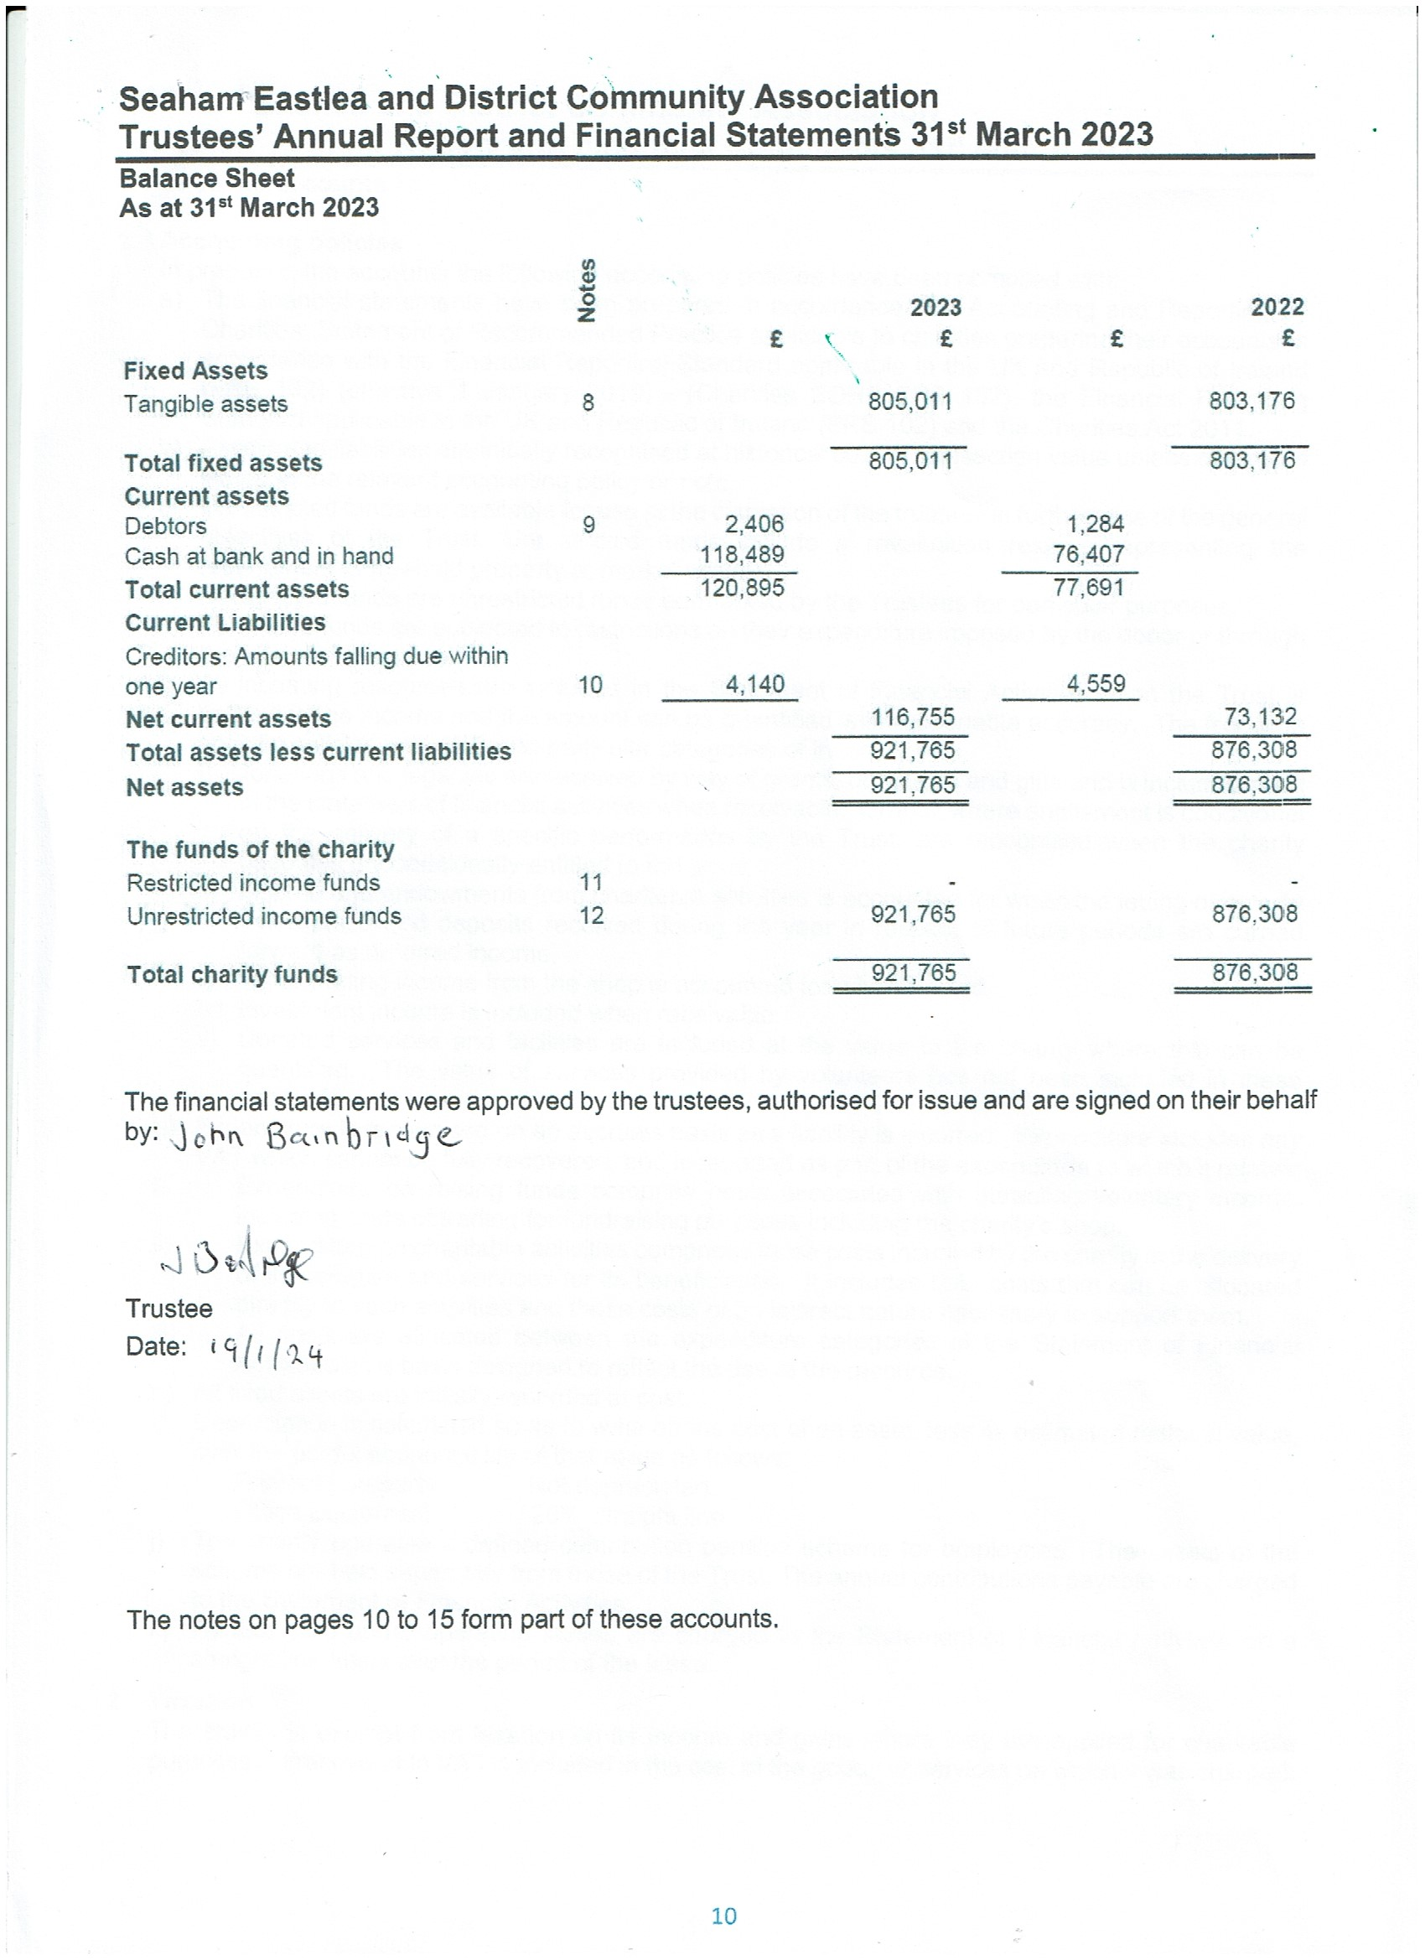
Seaham Eastlea and District Community Association
Trustees’ Annual Report and Financial Statements 31st March 2023
Notes to the accounts
1
Accounting policies
In preparing the accounts the following accounting policies have been complied with:
a)
The financial statements have been prepared in accordance with Accounting and Reporting by
Charities: Statement of Recommended Practice applicable to charities preparing their accounts in accordance with the Financial Reporting Standard applicable in the UK and Republic of Ireland (FRS 102) (effective 1 January 2019) - (Charities SORP FRS 102), the Financial Reporting Standard applicable in the UK and Republic of Ireland (FRS 102) and the Charities Act 2011. Assets and liabilities are initially recognised at historical cost or transaction value unless otherwise stated in the relevant accounting policy or note.
Unrestricted funds are available for use at the discretion of the trustees in furtherance of the general objectives of the Trust. Unrestricted funds include a revaluation reserve representing the
restatement of freehold property at market value.
Designated funds are unrestricted funds earmarked by the Trustees for particular purposes. Restricted funds are subjected to restrictions on their expenditure imposed by the donor or through the terms of an appeal.
All incoming resources are included in the Statement of Financial Activities when the Trust is entitled to the income and the amount can be quantified with reasonable accuracy. The following specific policies are applied to particular categories of income:
i) Donations and legacies are received by way of grants, donations and gifts and is included in full in the statement of financial activities when receivable. Grants, where entitlement is conditional
on the delivery of a specific performance by the Trust, are recognised when the charity becomes unconditionally entitled to the grant.
b)
c)
d)
e)
f)
ii)
Income and endowments from charitable activities is accounted for when the letting or activity
takes place and deposits received during the year in respect of future periods are carried forward as deferred income.
Other trading income from the shop is accounted for when earned. Investment income is included when receivable.
Donated services and facilities are included at the value to the charity where this can be quantified. The value of services provided by volunteers has not been included in these accounts.
iii)
iv)
v)
g)
Expenditure is recognised on an accruals basis as a liability is incurred. Expenditure includes any
VAT which cannot be fully recovered, and is reported as part of the expenditure to which it relates: Expenditure on raising funds comprise costs associated with attracting voluntary income,
including costs of trading for fundraising purposes including the charity’s shop.
Expenditure on charitable activities comprises those costs incurred by the charity in the delivery of its activities and services for its beneficiaries. It includes both costs that can be allocated
directly to such activities and those costs of an indirect nature necessary to support them.
All costs are allocated between the expenditure categories of the Statement of Financial Activities on a basis designed to reflect the use of the resource.
All fixed assets are initially recorded at cost.
Depreciation is calculated so as to write off the cost of an asset, less its estimated residual value, over the useful economic life of that asset as follows:
i)
ii)
iii)
h)
i)
Freehold property
Office Equipment
Not depreciated.
20% Straight line
j)
The charity operates a defined contribution pension scheme for employees. The assets of the
scheme are held separately from those of the Trust. The annual contributions payable are charged to the Statement of Financial Activities.
Rentals paid under operating leases are charged to the Statement of Financial Activities on a straight line basis over the period of the lease.
k)
2
Taxation
The charity is exempt from taxation on its income and gains where they are applied for charitable purposes. Irrecoverable VAT is included in the cost of the goods or services on which it was charged.
11

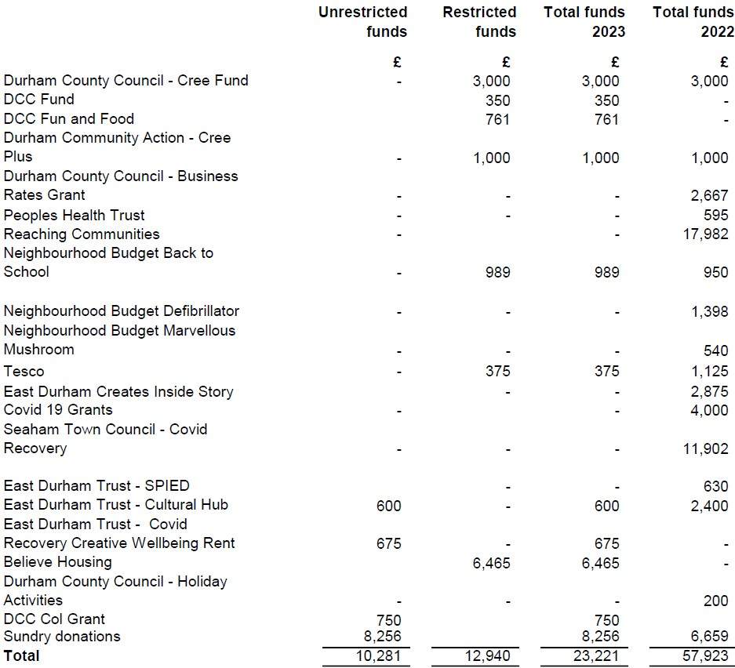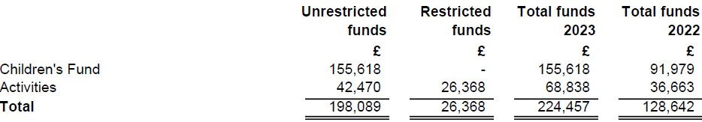
Seaham Eastlea and District Community Association
Trustees’ Annual Report and Financial Statements 31st March 2023
3
Income and endowments from: Donations and legacies
4
Income and endowments from: Charitable activities
Notes to the accounts (Continued)
12

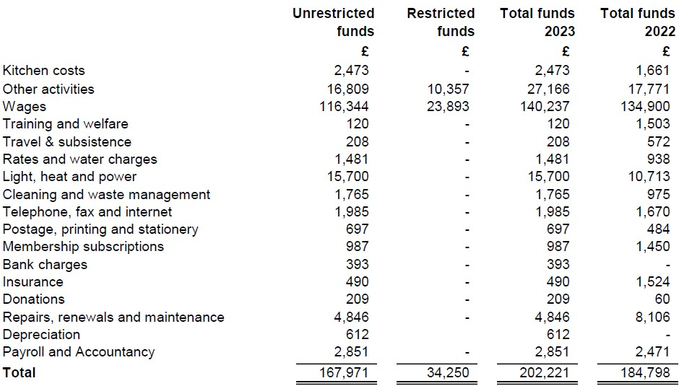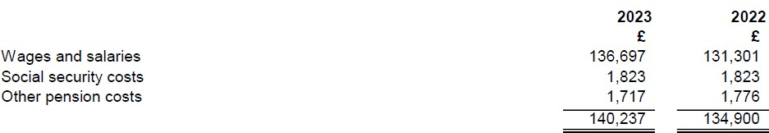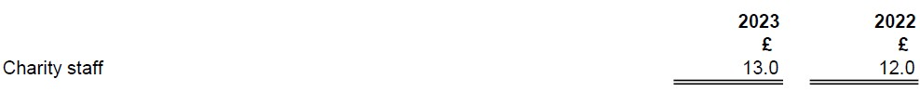
Seaham Eastlea and District Community Association
Trustees’ Annual Report and Financial Statements 31st March 2023
5
Expenditure on: Charitable activities
6
Employee information
No employee received emoluments in excess of £60,000 during the year (2022 nil). Employee costs during the period were as follows:
The average number of people employed during the period was as follows:
7
Trustee information
No trustee received remuneration (2022: none) or was reimbursed expenses (2022: nil) during the year.
Notes to the accounts (Continued)
13

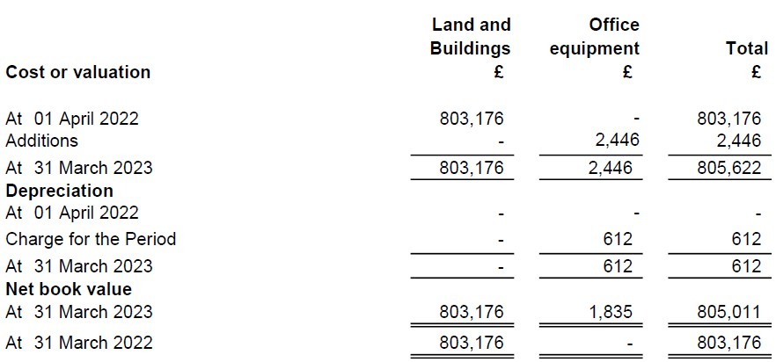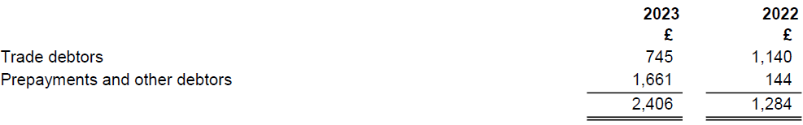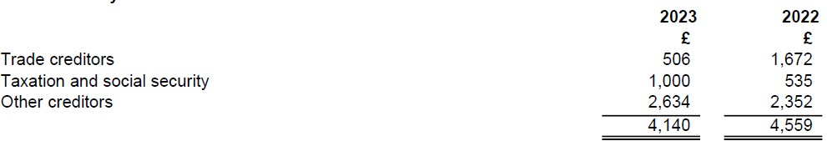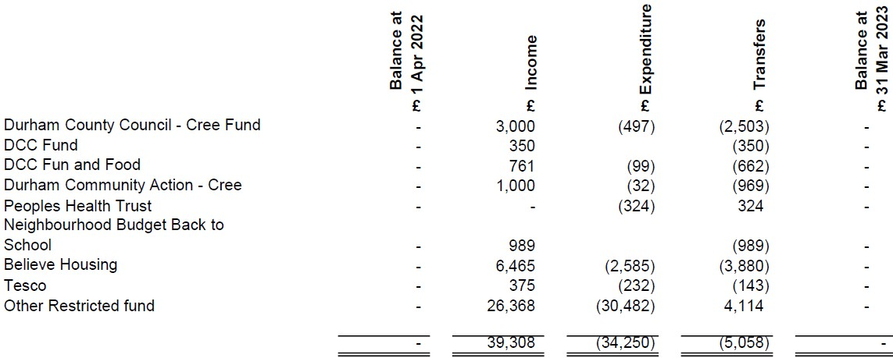
Seaham Eastlea and District Community Association
Trustees’ Annual Report and Financial Statements 31st March 2023
8
Fixed Assets
9
Debtors
All debtors are repayable within one year of the balance sheet date.

Creditors: Amounts falling due within one year
10
11
Restricted income funds
14

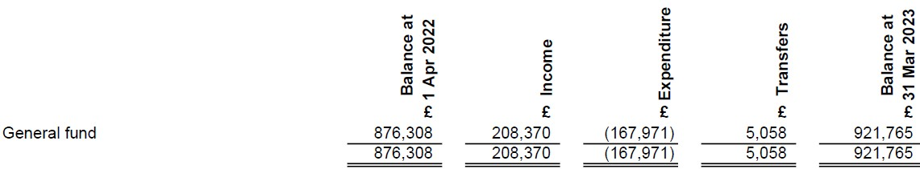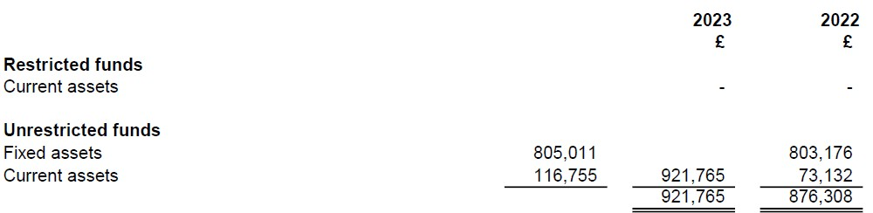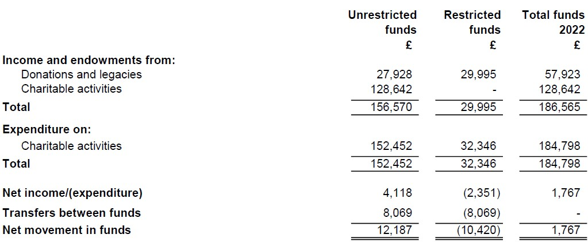
Seaham Eastlea and District Community Association
Trustees’ Annual Report and Financial Statements 31st March 2023
12
Unrestricted income funds
13
Analysis of net assets between funds
14
Related Party Transaction
There are no transactions with related parties that require disclosure.

Controlling Parties
The charity is controlled by the trustees.

Other Information
The charity is an unincorporated trust with its registered office at Eastlea Community Centre, Stockton Road, Seaham, Co Durham SR7 8DX.

Comparative Statement of Financial Activities by fund type (2022)
15
16
17
15

